January 24, 2017
Dear Members,
It is with great pleasure that I’m writing to inform you of an exciting change in the structure of our organization. In late 2016, at special meetings, the Canadian Newspaper Association (CNA) and the Canadian Community Newspaper Association (CCNA) voted, unanimously, to merge. The product of this merger is a new industry association, which will now be known as News Media Canada.
The decision to merge associations is one predicated on simplifying our governance structure. Rather than maintain two separate boards of directors, this move will consolidate representatives from community and daily, independent and corporate, newspaper across the country into one efficient board. In short, we will be more efficient, more sustainable and better able to represent all print and online news media in the country, from the smallest weekly to the largest daily.
What will not be affected by this transition, however, is the robust suite of value-added services we offer to members. This includes engaging marketing materials, insightful industry research, and public affairs advocacy.
We are working very hard to ensure this transition operates seamlessly. As a member of the CCNA or the CNA, your publication will automatically be enrolled as a member of News Media Canada, which will entitle you to all the same member benefits you currently enjoy. As well, the fee structure will remain the same effective January 1.
We are looking forward to the coming months as an excellent opportunity to reconnect with all of our members from coast-to-coast-to-coast. We will be rolling out new branding for the association and also have lots of exciting projects in store for 2017 and beyond. Should you have any questions or concerns, please contact info@newspaperscanada.ca.
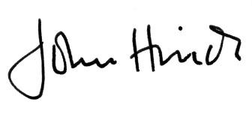
John Hinds,
President and CEO,
News Media Canada

